Reading stories to your child

What can you do to help at home?

- Read the same stories aloud again and again
- Read with enthusiasm – love each story
- Use a range of vocabulary with your child.

There are free video tutorials on our website – www.ruthmiskin.com

Select ‘More and International’ at the top, then ‘Home reading’ from the drop-down list:

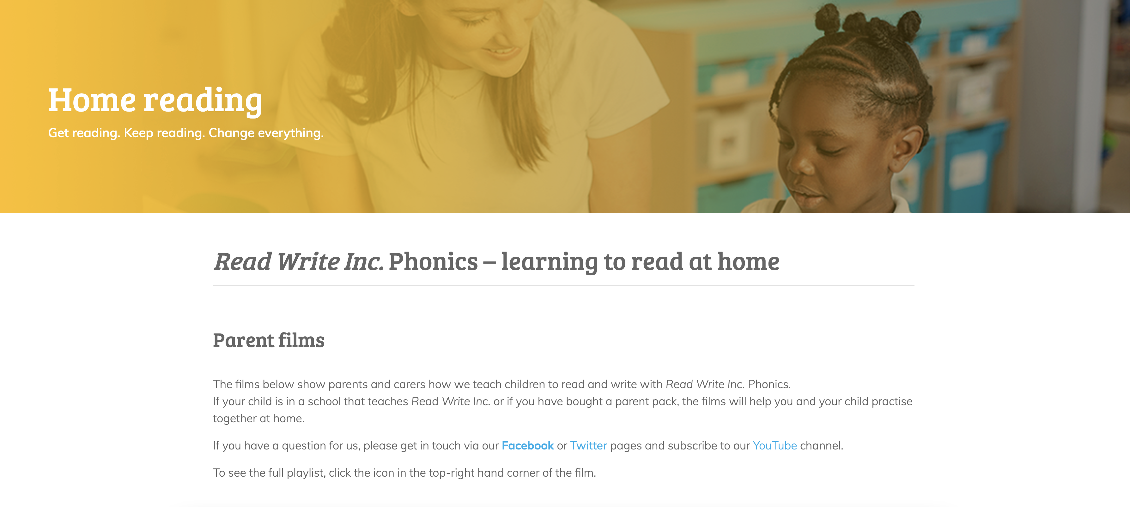

We’re also on Facebook – www.facebook.com/miskin.education

Free e-books for home reading:
http://www.oxfordowl.co.uk/Reading/

