Dean Valley Community Primary School

Hello my name is Mrs Katherine Dumbleton I am the Reception class teacher at Dean Valley Community Primary School. I have been involved with the school as a teacher and parent for many years. I love our school and I love my job. I have a real passion for learning through play and the skills and knowledge children develop during play.

I love spending time with my friends and family socialising, usually in the great outdoors. I love to walk and get outside as often as possible with my dog Meg. My family and I keep Pedigree Jacob sheep (the black and white one) which we care for and on occasions take to local agricultural show. Lambs usually come to visit us in our classroom. For the last few years the class and I have monitored the lambing shed using our live “lamb cam” in the classroom, eagerly watching for any new arrivals. I love to read “I read so I can live more than one life in more than one place.” This is an ethos I try to share with every child, as the more we read the more they learn, experience and wonder. I like to travel and see the world, I spend time learning about the places I want to go to and what we can experience there. I usually collect artefacts or items that can then be brought into school and used in our learning.

In our Reception classroom we have developed an environment that is inviting to all and offers something for everyone. We have construction areas including lego, writing and maths areas, art and craft area, woodwork table, mud kitchen, a cosy reading corner, outdoor climbing equipment, a stage and a role play area. The role play area is frequently changed to suit our learning. In past months it has been an ice palace, beach hut, builders yard, restaurant, airport and space station to name a few. I always aim to develop our learning following the ideas and interests of the children to make it as meaningful and enjoyable as possible.

I look forward to meeting you and your family soon.
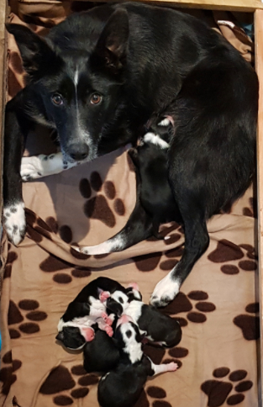
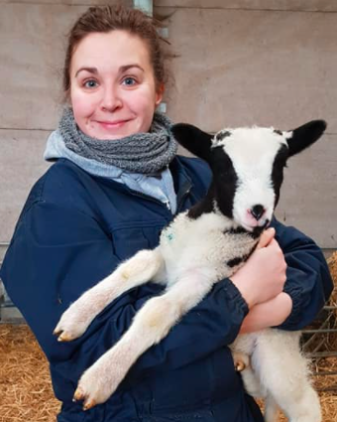
Mrs Dumbleton

